In every challenge lies an opportunity for growth.
This document applies Kaizen’s principle of embracing gaps and turning limitations into stepping stones. By seeing precisely where our processes fall short, we ignite continuous improvement and set a clear path to lasting success.


Prepared by: Daed Alqasem
Version: 02
Date: 08-Aug-2025
Table of Contents
Cover Letter 4
Why Kaizen Principles 5
Proven Accelerators 5
Delivery Excellence 5
Fully Certified Team 5
Regional & Global 5
RFP Compliance Matrix & Feasibility Summary 6
Registration & Approval 7
Operational Model 7
Customer Support 8
Reporting & Analytics 9
Core Interfaces & Integration 9
1 Registration & Screening 11
2 Service Catalogue & Ordering 12
3 Service Fulfilment & Task Management 12
4 Vendor Collaboration & Procurement 13
6 Customer Support & Live Chat 14
7 Governance, Documents & Approvals 15
Why It Matters for KUEC 15
Data-Migration & Cleansing Plan 16
Integration Architecture 17
Training Approach: “Explain → Show → Do → Coach” 17
Training Schedule Snapshot: 19
Assumptions & Exclusions 20
SLA & Support Model 20
Project Implementation Plan & Timeline 20
On-Site Discovery First 21
Functional Delivery Tracks 21
Key Milestones & Timeline 22
Execution Principles 22
Implementation Scope, Integrations, and Catalogue Rule Enforcement 23
Scope of Work 23
Effort and Timeline 24
Third-Party Systems and Integrations 25
Catalogue Updates – Administrator vs Developer Control 26
Operational Workflow Mapping Overview 26
Operational Workflow Mapping – Retainer / Service Package Fulfilment in Odoo 27
Operational Workflow Mapping – Project-Based Service Fulfilment in Odoo 32
Appendix C — Proposed UI Mockups (Odoo 18 EE Theme) 35
Conclusion 45

Cover Letter
Kaizen Principles is pleased to submit our formal response to the Request for Information (RFI) issued by Khalifa University Enterprises Company (KUEC) for the development of a Partner Self-Service Catalog Portal. We regard KUEC as a beacon of innovation within the UAE’s knowledge economy, and we welcome the opportunity to contribute to this forward-looking initiative.
Over the past decade, Kaizen Principles has earned a reputation for delivering comprehensive, enterprise-class solutions that harmonize robust technology with intuitive user experiences. Our multidisciplinary team combines expertise in portal design, ERP/CRM integration, and data-driven service automation—capabilities that align precisely with the functional and operational requirements outlined in your RFI.
We are committed to providing a platform that is efficient, scalable, and seamlessly integrated with the distinctive aesthetic and innovative spirit that defines KUEC. Enclosed you will find our detailed proposal, including project plans, milestone timelines, and a preliminary budget framework. These elements have been tailored to ensure the portal’s successful delivery while safeguarding schedule, quality, and cost.
We believe our approach supports KUEC’s mission to foster a future-oriented mindset and drive technological advancement across your stakeholder network. Thank you for considering our submission. We look forward to the possibility of collaborating with KUEC and stand ready to discuss any aspect of our proposal at your convenience

Why Kaizen Principles

Proven Accelerators
Kaizen Principles brings 24 plug-and-play “ready-made solutions” and a library of 4,500+ pre-built developments that span every standard Odoo application. These assets shorten lead-times, cut risk, and allow us to focus project effort on the 10–20 % of functionality that is truly unique to your business.

Delivery Excellence
Metric | Credential Detail
Project success rate | 100 % on-time, on-scope, go-live across all engagements.
Odoo recognition | Nominated Best Starter; Gold Partner status maintained since first accreditation—never downgraded.
Team certifications | PMP-certified project managers • Six Sigma Black Belts for process optimization • ISO-qualified implementation methodology (ISO 9001 & ISO 27001 frameworks).

Fully Certified Team
Every consultant, developer, and QA analyst on your project holds current Odoo functional and technical certifications, ensuring adherence to best practices and maintainable code.

Regional & Global
Presence Headquartered in Dubai with delivery hubs in the UAE, Saudi Arabia, Egypt, India, and Pakistan, we support clients locally while providing around-the-clock development and support coverage.

Consulting-First Approach
Before any line of code is written, our consultants map and streamline your internal processes, SLAs, and controls. Automation only follows once workflows are lean, compliant, and measured, guaranteeing that technology amplifies, rather than masks, operational excellence.

RFP Compliance Matrix & Feasibility Summary
The following Compliance Matrix provides a line-by-line assessment of KUEC’s functional and technical requirements against Odoo 18 Enterprise Edition. For each item, we indicate one of four feasibility states:
Indicator | Meaning | Typical Effort
Standard | Fully supported by Odoo (configuration only). | Basic configuration & onboarding
Development | Achievable through customization in Odoo (Python/OWL, Studio, or bespoke modules). | Moderate development & QA
Integration | Requires interfacing Odoo with an external system or third-party service. | API work, middleware, testing
Gap / No | Not available in native Odoo. Substantial custom development or alternative tooling would be required. | Significant project scope
Important clarification:
Whenever the matrix shows “No,” it denotes that the requested capability does not exist in Odoo’s standard feature set. Achieving that requirement would therefore necessitate either (a) a dedicated custom module that extends Odoo far beyond typical configuration, or (b) the adoption of a specialist third-party platform.
This structured view enables KUEC to quickly gauge feasibility, budget impact, and risk for each requirement, ensuring transparent expectations before project kickoff.

Registration & Approval
Req ID | Requirement Description | Covered in Odoo? | Odoo Fit
1 | Start-up Registration (portal form & docs) | Yes | Standard
2 | Start-up Registration Approval workflow | No | Development
3 | Start-up Sign-Up / Portal onboarding | No | Development
4 | Service Vendor Registration | No | Development
5 | Vendor Approval by Procurement | Yes | Standard
6 | Vendor Account Activation & Dashboard | Yes | Standard
7 | Automatic Notifications on registration | Yes | Standard
8 | Cancel / Disqualify Start-up (≤ 1 yr) | No | Development
9 | Cancel Approved Vendor & final billing | No | Development

Operational Model
Req ID | Requirement Description | Covered in Odoo? | Odoo Fit
10 | Customer profile & segmentation | No | Development
11 | Vendor classification & star rating | No | Development
12 | Service/package pricing with discounts | Yes | Standard
13 | Smart service-to-vendor routing | No | Development
14 | Onboarding package (22 services) | No | Development
15 | Service catalogue browsing | Yes | Standard
16 | Business-matrix eligibility rules | No | Development
17 | Purchase package/request quotation | Yes | Standard
18 | CRM update after purchase | Yes | Standard
19 | Auto / manual service assignment | No | Development
20 | Fulfilment journeys (project & retainer) | No | Development
21 | SR communication thread & docs | Yes | Standard
22 | Customer satisfaction survey | Yes | Standard
23 | Iterative service-card deployment | No | Development
24 | Service cancellation & refund flow | No | Integration
25 | Wallet/card refund (on-time payers) | No | Development
26 | Invoice cancellation (on-account) | Yes | Standard

Customer Support
Req ID | Requirement Description | Covered in Odoo? | Odoo Fit
27 | Chat widget & ticket logging to CRM | Yes | Standard
28 | Auto SR creation (chat / call) & merge | Yes | Standard
29 | SR reassignment & team views | Yes | Standard

Reporting & Analytics
Req ID | Requirement Description | Covered in Odoo? | Odoo Fit
30 | Revenue tracking (monthly/yearly) | Yes | Standard
31 | Revenue by vertical / parameters | Yes | Standard
32 | Tracking & cost codes | Yes | Standard
33 | P&L per account | Yes | Standard
34 | SLA compliance reports | No | Development
35 | Support-transaction volumes | Yes | Standard
36 | Backlog SRs exceeding SLA | Yes | Standard
37 | Customer-satisfaction dashboard | Partial | Standard + Integration

Core Interfaces & Integration
Req ID | Requirement Description | Covered in Odoo? | Odoo Fit
I-1 | Enterprise CRM workspace | Partial | Standard + Development
I-2 | Vendor portal (registration, KPIs, payments) | No | Development
I-3 | Customer self-service portal | Partial | Standard + Development
I-4 | ERP/API integrations & scalability | No | Integration

Note:
“Covered in Odoo? = No” indicates that the capability is not available in Odoo out of the box and will need either custom development or an external integration to meet KUEC’s specification.

Odoo Standard Possible Utilization – Tailored to KUEC Center of Excellence (CoE)
In this section, we show how the core Odoo 18 Enterprise apps can be linked together. like stations on a single track to support KUEC’s end-to-end Shared-Services Portal life-cycle:
- Registration & Screening (Website Forms → Portal → CRM)
- Service Catalogue & Ordering (eCommerce / Sales → Subscriptions)
- Service Fulfilment (Project / Helpdesk / Field Service)
- Vendor Collaboration & Procurement (Purchase → Invoicing)
- Finance & Reporting (Accounting → Spreadsheet → Power BI)
- Customer Support & Satisfaction (Discuss → Survey)
- Governance & Compliance (Documents, Approvals, Studio)
Rather than listing features in isolation, we kept each BRD requirement in view, mapped it to the closest out-of-the-box module, and described the hand-off that occurs when data moves from one module to the next. The objective is a practical playbook that shows where configuration alone delivers value, and where customization or external integration is unavoidable.

1 Registration & Screening
BRD Theme | Odoo Flow (Standard) | Key Built-in Features
Start-up / Vendor On-Boarding | Website > Form Builder captures registration data > auto-creates Partner record in Contacts > routes to CRM stage “Screening”. | CAPTCHA, attachment upload, GDPR consent, Server Action emails, Innovation & Procurement teams.
Approval Gate | Reviewer moves record to “Approved” stage; Approvals app logs decision & comments. | Multi-level approvals, activity scheduling, full audit trail.
Portal Activation | Portal invitation sent automatically; registrant sets self-password, sees personalized dashboard. | Single Sign-On (SAML/OAuth optional).
Auto-Notify | Automated Actions trigger system mails/chatter messages on stage change. | HTML templates per actor (Start-up, Investor, Vendor).

2 Service Catalogue & Ordering
BRD Theme | Odoo Flow (Standard) | Key Built-in Features
Catalogue Browsing | Website Shop / eCommerce lists “Service Packages” filters by Governmental vs Non-Governmental, Delivery Mode, and Eligibility. | Pricelists, attribute filters, -and multi-currency.
Eligibility Matrix | The portal user enters or already holds tags (“Subsidiary”, “Startup”). Website Builder shows only eligible items via the Domain filter. | Dynamic publish rules; no code needed.
Package Subscription / Retainer | “Subscribe” button converts to Sales → Subscription contract with billing cycle (monthly/annual). | Automatic invoicing, payment tokens, and renewal alerts.
Quote for Project-Based Service | RFP button opens Sales Quotation form; CoE Coordinator completes scoping; quote emailed to customer. | Sign on quote: online payment of deposit.

3 Service Fulfilment & Task Management
BRD Theme | Odoo Flow (Standard) | Key Built-in Features
Project-Based Services | Sales Order confirmation spawns a Project with tasks & milestones. | Gantt / Kanban views, project profitability.
Retainer / Ticketed Services | Subscription auto-creates a Helpdesk ticket each month, OR lets the customer raise an SR manually in the Portal. | SLA timers, timesheets, and billable hours.
22-Step Onboarding Package | Pre-configured Project Template (22 tasks) imported at startup profile approval. | Task checklist widget, progress bar.
Service Communication Thread | Every task/ticket has its own Discuss channel; vendor staff are added as followers from the Vendor Portal. | File sharing, emoji, @mentions.
Customer Satisfaction | On task/ticket closure, the Survey app auto-sends a 5-point CSAT form; scores feed Kanban ‘Happy / Neutral / Unhappy’. | Conditional questions, dashboard.

4 Vendor Collaboration & Procurement
BRD Theme | Odoo Flow (Standard) | Key Built-in Features
Vendor Registration & Rating | Vendor record created, Purchase tags hold Service Categories; custom “Stars” field via Studio. | Vendor pricelists, scorecards.
Smart Routing | Python rule (custom) assigns incoming SR to preferred vendor; rule taps vendor category & star rating. | (Custom logic sits on top of Purchase / Project).
PO & 3-Way Match | CoE Coordinator approves vendor’s proposal > auto-creates Purchase Order > Goods Receipt > Vendor Bill matched. | Duplicate-bill blocking, price variance warnings.

5 Finance, Wallets & Reporting
BRD Theme | Odoo Flow (Standard + BI) | Key Built-in Features
Billing & Refunds | Subscription invoices auto-post to Accounting; credit-note wizard handles cancellations; payment acquirer refunds card (API). | Payment tokens, multi-currency, and Partial refunds.
On-Time Payer Wallet | Simple “Wallet” analytic account holds credit balance; applied on next invoice (custom but lightweight). | Analytic defaulting, negative invoice lines.
Revenue / Cost / P&L | Spreadsheet template pulls live data from Accounting, Purchase; publishes to Power BI via connector. | Pivot caching, scheduled exports.
SLA & Backlog KPIs | Helpdesk KPIs exposed via Odoo’s /JSON RPC; Power BI dataset refreshes nightly. | Native SLA statistics, tag filtering.

6 Customer Support & Live Chat
BRD Theme | Odoo Flow (Standard + Integration) | Key Built-in Features
Live Chat Widget | Odoo Live Chat embeds on portal pages; on the/helpdesk channel, join it creates a ticket automatically. | Chatbot hand-over, canned replies.
Call Logging | Odoo VOIP module logs inbound calls; missed call triggers a Helpdesk ticket. | Asterisk / SIP integration.
Ticket Merge | Built-in “Merge Tickets” wizard groups duplicates; SLA clock preserves the oldest timestamp. | Drag-drop merge, chatter history preserved.

7 Governance, Documents & Approvals
BRD Theme | Odoo Flow (Standard) | Key Built-in Features
Service Cards & Version Control | Each service has a Product Template; CoE Admin edits via Studio; revisions are tracked in Documents. | Check-in/out, versioning.
Digital Approvals | Approvals app routes POs, price exceptions, vendor onboarding forms; fully timestamped. | PDF attachments, resubmit loop.
Policy & License Repository | All master data (licenses, policies) are stored in Documents with expiry alerts 60 days prior. | Access groups, tag search.

Why It Matters for KUEC
- Faster Go-Live – 80 % of the CoE requirements align with native Odoo workflows; configuration delivers value before custom code starts.
- Single Source of Truth – Contacts, SRs, projects, invoices, and surveys all share the same database, cutting manual reconciliations.
- Scalable Roadmap – Future AI routing, vendor chatbots, or advanced BI dashboards can plug into the same API layer with minimal refactoring.
Whenever a BRD line item genuinely exceeds standard capability, we have flagged it in the Compliance Matrix as Development or Integration; otherwise, the tables above demonstrate how Odoo Standard can be deployed immediately to cover core CoE processes.

Data-Migration & Cleansing Plan
We will migrate all legacy customer, vendor, and service‑catalogue data into Odoo in a three‑wave approach:
Wave | Source Systems | Target Models | Cleansing & Validation Steps | Owner
1 | Excel master lists (Start-ups, Subsidiaries, Vendors) | (Contacts) incl. tags for Eligibility & Customer Class | • Remove duplicates• ISO address / phone format• Emirate & license-number regex checks | KUEC Data + Kaizen
2 | Current SR tickets (SharePoint / Mailbox) | helpdesk.ticket + attachments | • Map old categories to new Service Codes• Auto-assign historic SLA outcomes | Kaizen
3 | Historical invoices & vendor bills (ERP) | account.move | • Balance control accounts• Tie to analytic tags for cost center P&L | KUEC Finance

Integration Architecture
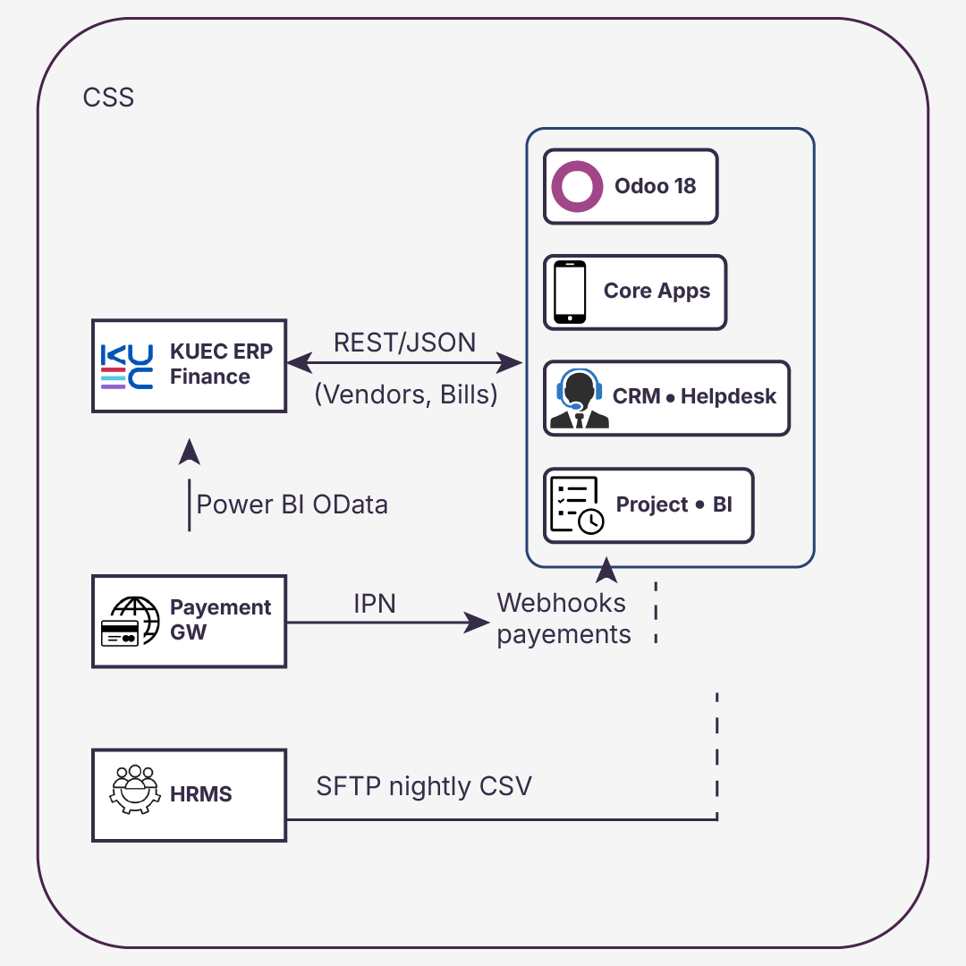

Training Approach: “Explain → Show → Do → Coach”
Kaizen Principles will deliver a structured training program to ensure all KUEC user groups—internal teams, vendors, and customers—are confident and self-sufficient in using the new portal and back-office system. Our approach is based on the “Explain → Show → Do → Coach” model, which maximizes both knowledge retention and real-world application.
Phase 1: Explain
We begin each training module by clearly explaining the why and what behind the system feature or process.
- 10–15 minute briefing sessions aligned to real KUEC use cases (e.g., registering a startup, routing a service request).
- Delivered live or pre-recorded via Google Meet.
- Materials: PDF Quick Reference Guides, Arabic & English.
Phase 2: Show
Next, we demonstrate the feature live in the system, using Demo data and the actual KUEC configuration.
- Step-by-step walkthroughs in Odoo (e.g., confirming a purchase order, responding to a vendor quote).
- Recorded screen shares added to KUEC’s internal training library.
- Split by role: CoE Coordinator, MIS Analyst, Vendor, Customer.
Phase 3: Do
Users then practice the process themselves inside the UAT (test) environment.
- “Role-play” exercises: simulate SR routing, service delivery milestones, vendor invoice processing.
- Users follow the process with guidance materials but without intervention.
- Hands-on tasks are tracked via checklists to monitor progress and identify knowledge gaps.
Phase 4: Coach
Finally, our trainers observe and provide 1:1 or small-group coaching sessions to reinforce learning.
- Shadowing during the pilot phase (e.g., watch the first vendor onboarding or ticket resolution).
- Corrections and tips offered live, with a follow-up summary sent to each participant.
- This phase continues into Week 1 of go-live as part of the Hypercare plan.

Training Schedule Snapshot:
Audience | Training Format | Language | Duration | Materials
CoE Coordinators | Live + recorded | EN/AR | 3 x 1.5h | Role manual, videos
Vendors | Video + sandbox tasks | EN/AR | Self-paced | Portal guide, checklist
Internal Departments | Live session + follow-up | EN/AR | 1 x 2h | Process map, SOP
Startups / Customers | Walkthrough videos in the portal | AR preferred | < 10 min each | FAQ, in-app video
This model ensures each user learns not just where to click, but when, why, and what to do next, reinforcing KUEC’s vision of a modern, intuitive, and service-focused digital experience.

Assumptions & Exclusions
# | Assumption / Exclusion | Impact if False
A1 | Legacy data provided in agreed format before Sprint 1 | Timeline slip ≈ 1 week
A2 | Payment gateway onboarding starts in Week 1 | Delay in go-live payments
E1 | Arabic translations for UI provided by KUEC | Minor delay in UI delivery

SLA & Support Model
Tier | Example | Response | Resolution | Escalation
L1 | Password reset | 1 h | 4 h | –
L2 | Minor bug | 4 h | 1 bd | L3 after 8 h
L3 | Outage | 30 min | 4 h | CTO

Project Implementation Plan & Timeline
This section outlines our proposed compressed implementation roadmap, designed to deliver the entire KUEC CoE Shared Services Portal in under 2 calendar months.
Rather than spreading delivery across traditional agile sprints, we have structured the work into four functional implementation tracks, each with focused teams working in parallel to accelerate time to value.
The schedule is anchored to a 2 September 2025 kickoff. All milestones are subject to adjustment based on KUEC resource availability, data readiness, or integration partner alignment.

On-Site Discovery First
The project begins with a 5-day on-site Discovery & Alignment workshop during the first week of September. This workshop is attended by key stakeholders across CoE Coordination, MIS, Procurement, and Finance.
Objectives include:
- Finalizing scope and ownership per the BRD requirement
- Validating data structure, user stories, and business rules
- Confirming acceptance criteria and reporting expectations
This ensures that the upcoming configuration and development work is rooted in real user context, reducing risk and rework.

Functional Delivery Tracks
Track | Duration | Key Deliverables
Track 1: Registration & Interfaces | 2 Sept – 27 Sept | Startup/vendor registration flows, approval engine, portal activation, role-based views (Customer, Vendor, CoE Coordinator)
Track 2: Catalogue & Logic | 2 Sept – 30 Sept | Service catalogue (gov + non-gov), subscription model, pricing rules, eligibility filters, smart routing logic
Track 3: Fulfilment & Support | 9 Sept – 10 Oct | Onboarding packages, project-based and retainer fulfilment journeys, helpdesk workflows, and customer satisfaction surveys
Track 4: Finance & Reporting | 16 Sept – 28 Oct | Wallet & refund engine, invoice logic, integration touchpoints (ERP & payment), Power BI datasets (SLA, revenue, CSAT)

Key Milestones & Timeline
Date | Milestone
2 Sept 2025 | Project Kickoff & Discovery Workshop
13 Sept 2025 | Registration Module UAT Start
25 Sept 2025 | Catalogue Logic Fully Configured
10 Oct 2025 | Fulfilment & Support Demo Sign-Off
20 Oct 2025 | Finance Logic Ready for Validation
28 Oct 2025 | Full System Go-Live
1–15 Nov 2025 | Hypercare, knowledge transfer, and Go-Live extension to all users

Execution Principles
- Parallel teams are assigned per track to maximize velocity
- Shared project board (Odoo Project) visible to KUEC and Kaizen team for daily tracking
- Weekly RAID log reviews with KUEC leadership
- All major releases are tested and staged on UAT before go-live
- Arabic and English UI/UX validated in each module

Implementation Scope, Integrations, and Catalogue Rule Enforcement
This section outlines the work that will be delivered, the estimated effort and timeline, the third-party systems involved, and the technical approach for enforcing KUEC’s Service Catalogue rules within Odoo. It also identifies any non-standard coverage and clarifies which updates can be managed by administrators versus those requiring developer involvement.

Scope of Work
Scope Item | Approach | Description | Effort (Days)
Service Catalogue Filters | Custom | Implement filters for Governmental/Non-Governmental, Delivery Mode, Eligibility, and Service Code within the portal and shop. | 4
Smart Routing Rules | Custom | Automatically assign vendors based on category, rating, and eligibility criteria. | 3
Onboarding Checklist | Custom | 22-step onboarding checklist linked to service requests and SLA tracking. | 4
Retainer Fulfilment Flow | Config + Custom | Automate recurring service requests with SLA monitoring. | 5
Dispute Resolution View | Config + Custom | Portal view for managing disputes with escalation paths. | 3
Customer Support Chat & Ticket Merge | Custom | Embedded chat tool with the ability to create service requests and merge duplicate tickets. | 4
Vendor Payment & CSAT Dashboard | Config + Custom | Vendor portal section for viewing payments and customer satisfaction scores. | 3
Admin Catalogue & Rule Configuration | Config + Custom | Administration screens to manage eligibility rules, pricing, and vendor routing logic. | 4

Effort and Timeline
The total estimated effort is approximately 30–35 Man-days. Delivery will follow the schedule already outlined in the Project Implementation Plan & Timeline section, anchored to a 2 September 2025 kickoff and a go-live date of 28 October 2025.
The implementation will be delivered within the same milestones, including:
- Parallel delivery across functional tracks (Registration & Interfaces, Catalogue & Logic, Fulfilment & Support, Finance & Reporting).
- Completion of all configurations, custom developments, integrations, testing, and training within the 2-month delivery window.

Third-Party Systems and Integrations
System | Method | Purpose | Key Risks
Payment Gateway (e.g., Network International) | REST API via Odoo Payment Acquirer | Process online payments | Possible downtime or SLA delays
Government Systems (status checks, validation, licensing) | If API is provided: Direct REST/SOAP integration using Odoo’s standard API framework (XML-RPC/JSON-RPC). If no API is provided, Manual data exchange or upload/download through the portal. | Automate service status checks, license verifications, and other regulatory validations. | Dependency on government API availability, authentication changes, or data format updates.
Document Verification Services | REST API via Odoo connector | Validate trade licence and compliance documentation | Changes to API specifications
Power BI | OData/SQL connector from the Odoo database | Provide BI dashboards and analytics | Data refresh or connection failures

Catalogue Updates – Administrator vs Developer Control
Update Type | Admin | Developer
Service descriptions, pricing, eligibility lists, categories | ✔ | —
Adding or removing services | ✔ | —
Adjusting vendor assignments in routing rules | ✔ | —
Adding new attributes to the service code structure | — | ✔
Changing the logic behind smart routing | — | ✔
Adding new third-party integrations | — | ✔

Operational Workflow Mapping Overview
To complement the technical scope and catalogue enforcement plan, the following tables map KUEC’s core service fulfilment workflows directly to Odoo 18 Enterprise features. Each step in the process is shown with its corresponding Odoo module, whether it is delivered using standard functionality or requires customization, a description of its function in the workflow, key technical details, and the expected outcome. This ensures full transparency on how day-to-day operations will be executed within Odoo and where development effort will be focused.

Operational Workflow Mapping – Retainer / Service Package Fulfilment in Odoo
Step / Condition in Flow | Odoo Module / Feature | Type | Function in Workflow | Technical Details | Outcome
1. Select the service package | Website / Portal + Custom Service Catalogue | Custom + Config | The customer chooses a service package from the portal. | Portal pulls records from service.catalogue.item model, eligibility, and delivery mode filters are applied dynamically. | Ensures that customers only see valid packages for which they are eligible to request.
2. Select service duration (monthly/annual) | Subscription | Standard | Capture subscription length. | Duration field tied to subscription template linked to selected service. | Automates billing cycle setup.
3. Accept terms & conditions | Website Checkout | Config | Customer agrees to the service T&Cs. | A mandatory checkbox field is stored on the sales order, preventing submission if it is not checked. | Legal acceptance is logged in the backend.
4. Sign predefined service contract | eSign / Documents | Standard | Sign the contract before payment. | Contract template pre-filled with customer/service details; eSign workflow initiated. | Signed PDF stored in Odoo Documents.
5. Pay for the service | Website Payment | Standard | Process payment online. | The integrated payment gateway processes the transaction; Odoo updates the payment status. | Immediate confirmation of payment.
6. Receive confirmation & receipt | Invoicing / Email | Standard | Send proof of purchase. | Auto-generated invoice emailed; chatter post on sale order with PDF attached. | Transparent financial documentation.
7. Notify L1 CoE Coordinator | Discuss / Activity | Standard | Alert the coordinator for action. | Activity is auto-created in the coordinator's to-do list upon payment confirmation. | The coordinator is ready to initiate package confirmation.
8. Perform package confirmation call | CRM / Activities | Standard | Verify order details with the customer. | Call logged as CRM activity linked to subscription; notes stored in Chatter. | Confirms accuracy before fulfillment.
Condition: Successful? | — | — | Decision point. | If “No”, triggers meeting (Step 9); if “Yes”, moves to vendor notification (Step 11). | Logical branching in process.
9. Meeting with requester | Calendar / Meetings | Standard | Resolve unclear details. | Meeting scheduled in Odoo Calendar with the requestor & coordinator. | Aligns expectations before fulfilment.
Condition: Purchase confirmed? | — | — | Decision point. | If “No”, refund process initiated (Step 10). | Avoids wasted vendor effort.
10. Start the refund process | Invoicing / Accounting | Standard | Reverse transaction. | Credit note issued; payment reversal triggered in the payment. | Customer refunded, process closed.
11. Automatic vendor notification for fulfilment | Project / Task Assignment | Custom Automation | Assign a vendor to deliver the service. | Rule-based routing assigns vendor tasks in the project module based on service attributes. | Fast and accurate fulfilment assignment.
12. Serve deliverables | Project / Documents | Standard | Complete and deliver work. | Vendor updates project task; uploads deliverables to Documents. | Deliverables are accessible to the customer.
13. Capture customer feedback | Survey / Rating | Standard | Collect post-service feedback. | Survey auto-sent upon task completion; results stored in service request record. | Customer satisfaction metrics captured.
Condition: Positive? | — | — | Decision point. | If “No”, triggers feedback call (Step 14). | Enables service recovery.
14. Perform feedback call | CRM / Activities | Standard | Resolve customer concerns. | Call scheduled and logged as CRM activity linked to SR. | Builds trust, attempts issue resolution.
Condition: Issue resolved? | — | — | Decision point. | If “Yes”, end process; if “No”, escalate to vendor performance meeting (Step 15). | Clear escalation path.
15. Performance management meeting with vendor | Calendar / Meetings | Standard | Address vendor performance. | Meeting logged against vendor record; minutes stored in Documents. | Drives vendor accountability.
Condition: Issue resolved? | — | — | Decision point. | If “No”, escalate to investigation meeting (Step 16). | Maintains escalation discipline.
16. Investigation meeting with vendor | Calendar / Meetings | Standard | Conduct detailed investigation. | Meeting notes stored; corrective actions assigned in project tasks. | Identifies root cause.
Condition: Issue resolved? | — | — | Decision point. | If “No”, start vendor change process (Step 18). | Final escalation step.
17. End process | — | — | Process closure. | Mark service request as complete in backend. | Ensures data accuracy.
18. Start vendor change process | Purchase / Vendor Management | Custom + Config | Replace underperforming vendor. | Vendor deactivated; routing rules updated to exclude vendor. | Service continuity maintained.
19. Notify L2 CoE Coordinator | Discuss / Activity | Standard | Inform management of change. | Automated message to L2 coordinator. | Transparency in escalations.

Operational Workflow Mapping – Project-Based Service Fulfilment in Odoo
Step / Condition in Flow | Odoo Module / Feature | Type | Function in Workflow | Technical Details | Outcome
1. Filling the service request form | Website / Portal + Custom Service Request model | Custom + Config | Entry point for project-based work. | Portal form linked to service.request model; dynamic filters from Service Catalogue; file uploads to Documents. | Captures all essential project request data.
2. Review the scope | Project / CRM Activity | Standard | Validate initial request. | Coordinator reviews form data in project record; flags missing details. | Prevents unclear scopes from proceeding.
Condition: Scope is clear? | — | — | Decision point. | If “No”, schedule meeting (Step 3); if “Yes”, go to draft scope (Step 4). | Early clarity.
3. Meeting between requestor, CoE, and vendor | Calendar / Meetings | Standard | Clarify scope with all parties. | Meeting scheduled and linked to service request record. | Aligned understanding of requirements.
4. Draft the final scope document | Documents / Project | Standard | Prepare detailed scope. | Vendor/coordinator uploads scope file in Documents; linked to project. | Scope version control in place.
5. Process the scope amendments | Documents / Project | Standard | Update scope after feedback. | New document versions uploaded; tracked in chatter. | Traceable scope changes.
6. Scope document approved? | Approvals | Standard + Config | Formal approval workflow. | Approval request sent to designated approvers; logged decision. | Authorized scope before contracting.
Condition: Approved? | — | — | Decision point. | If “No”, return to amendments (Step 5); if “Yes”, go to Step 7. | Prevents unauthorized work.
7. Adding scope to pre-approved service contract template | eSign / Documents | Standard | Merge scope with contract. | Contract auto-generated with approved scope details. | Single source of truth for agreement.
8. Initiate contract signature process | eSign | Standard | Get signatures from all parties. | eSign request sent; status tracked in backend. | Legally binding contract executed.
9. Contract signature | eSign | Standard | Confirm readiness to start project. | Signed PDF stored in Documents; project status updated to “Active”. | Clear project commencement signal.
10. Project deliverables | Project | Standard | Execute work as per scope. | Vendor updates tasks, logs time, and attaches deliverables. | Progress and outputs recorded.
11. Deliverable review | Project / Quality Check (custom step) | Standard + Custom | Validate deliverables. | Coordinator reviews and approves/rejects deliverables in project. | Quality control before closure.
Condition: Approved? | — | — | Decision point. | If “No”, request modifications (Step 13); if “Yes”, close project. | Controlled acceptance.
12. Ask for modification | Project Task | Standard | Request changes from vendor. | Task moved to “In Progress”; comments in chatter. | Vendor clear on changes needed.
13. Process the amendments | Project Task | Standard | Implement change requests. | Vendor updates deliverables; attaches revised files. | Rework tracked.
14. Initiate alignment meeting with all parties | Calendar / Meetings | Standard | Ensure all agree on final deliverables. | Meeting scheduled; notes stored in Documents. | Consensus before final approval.

Appendix C — Proposed UI Mockups (Odoo 18 EE Theme)
The following visuals present conceptual user interface mockups of the KUEC Center of Excellence Self-Service Portal, designed in the official Odoo 18 Enterprise style.
They illustrate the complete workflow from portal entry to service request fulfilment, support, and administrative configuration.
Each mockup directly maps to functional requirements in the BRD and Service Catalogue, making it easier for all stakeholders to visualise how the proposed solution will look and operate.

Figure 01 — Portal Landing Dashboard
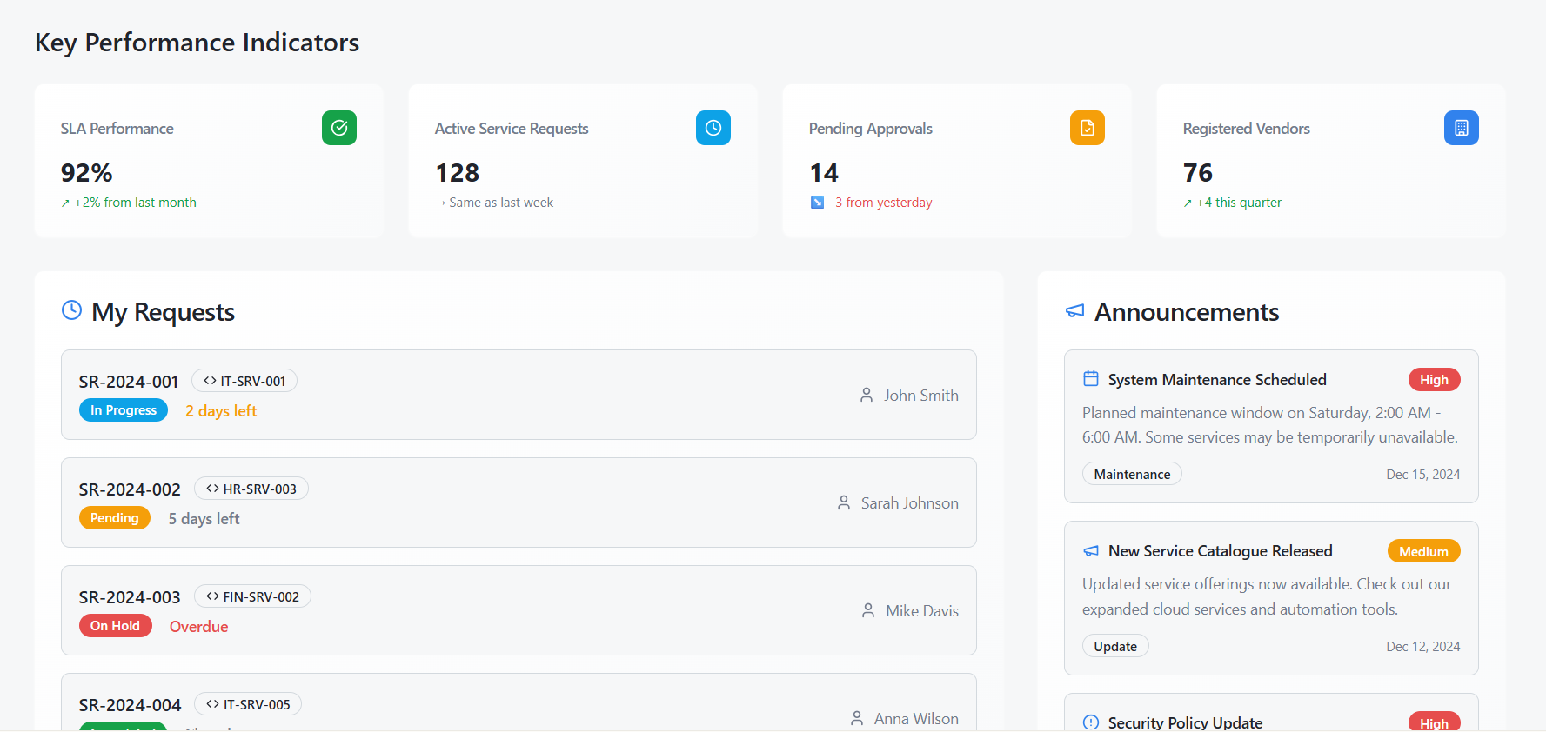

Figure 02 — Customer Registration (Start-Up)
Purpose: Allows new startup customers to register, upload compliance documents, and submit for eligibility screening. Progress bar shows completion (Company Profile → Documents).
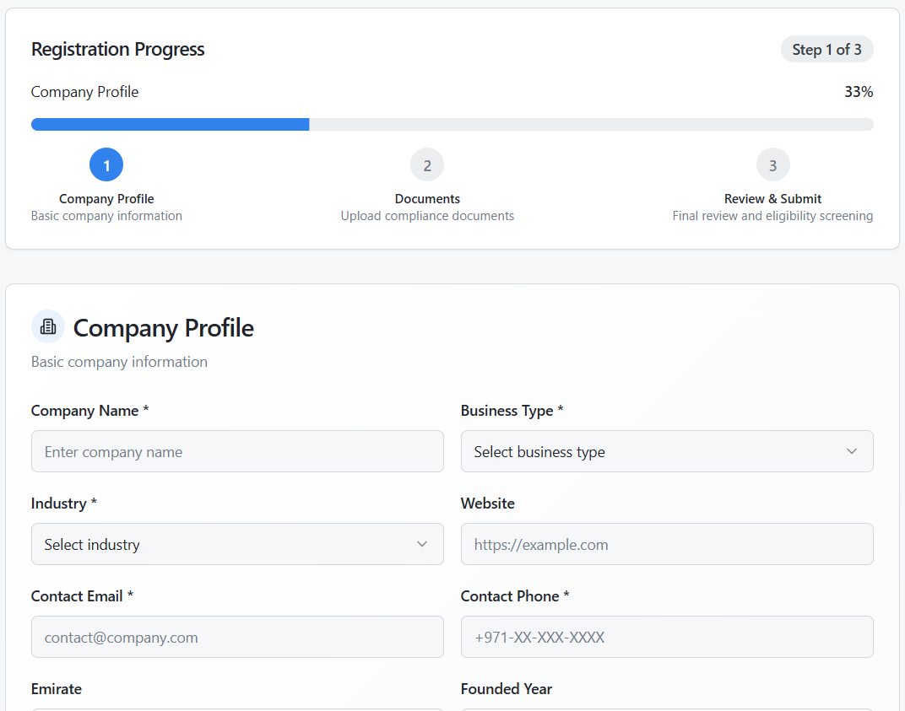

Figure 03 — Service Catalogue (Governmental & Non-Governmental)
Purpose: Let customers browse available services with filters for type, delivery mode, and eligibility. Each service card shows Service Code, title, and pricing, with a link to full details.
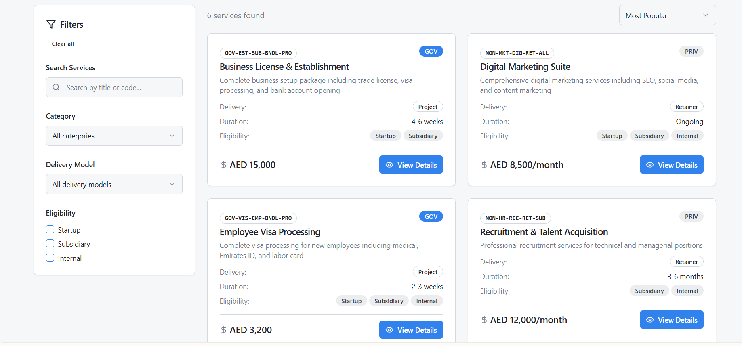

Figure 04 — Create Service Request
Purpose: Form to submit a new request. Supports Project-Based (scope, target date, budget) or Retainer (billing cycle, start date, wallet credit) modes.
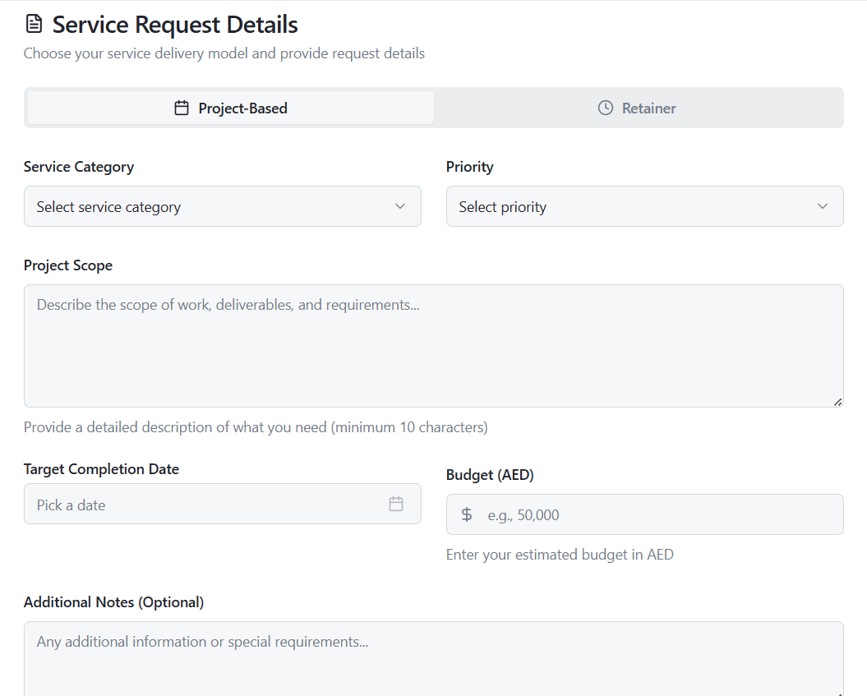
Figure 05 — Vendor Payments & CSAT
Purpose: Vendor view to track scheduled/paid payments linked to service milestones and review customer satisfaction scores by service.
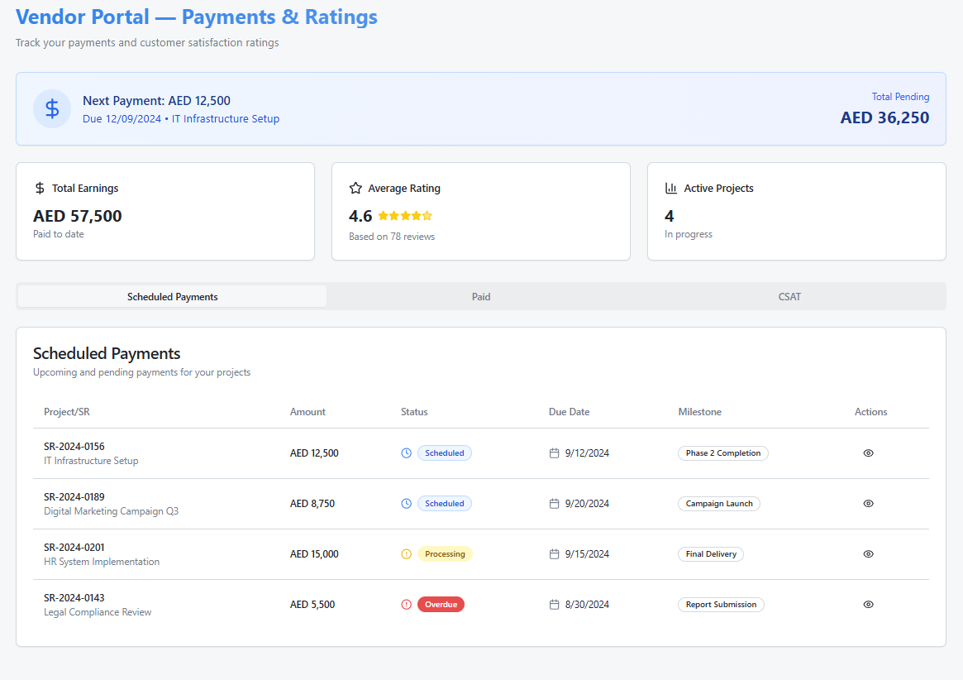
Figure 06 — Dispute Resolution Case
Purpose: Central case view for disputes between customer and vendor. Shows threaded communications, linked SR, reason, SLA target, and escalation actions.
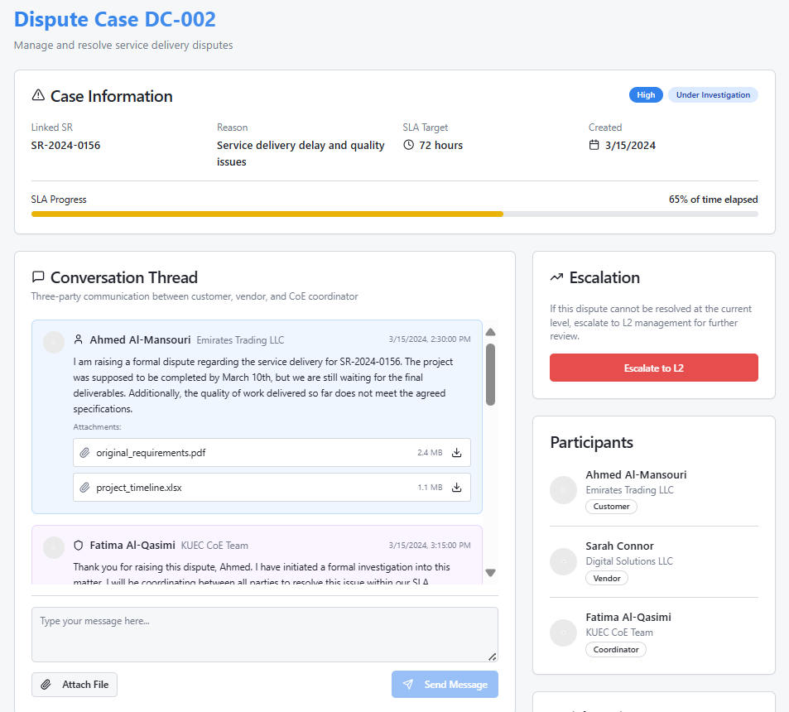

Figure 07 — Project-Based Fulfilment Orchestration
Purpose: Visualises the workflow of project-based services. Kanban columns (To Do, In Progress, Review, Done) show task stages; right mini-Gantt shows timelines.
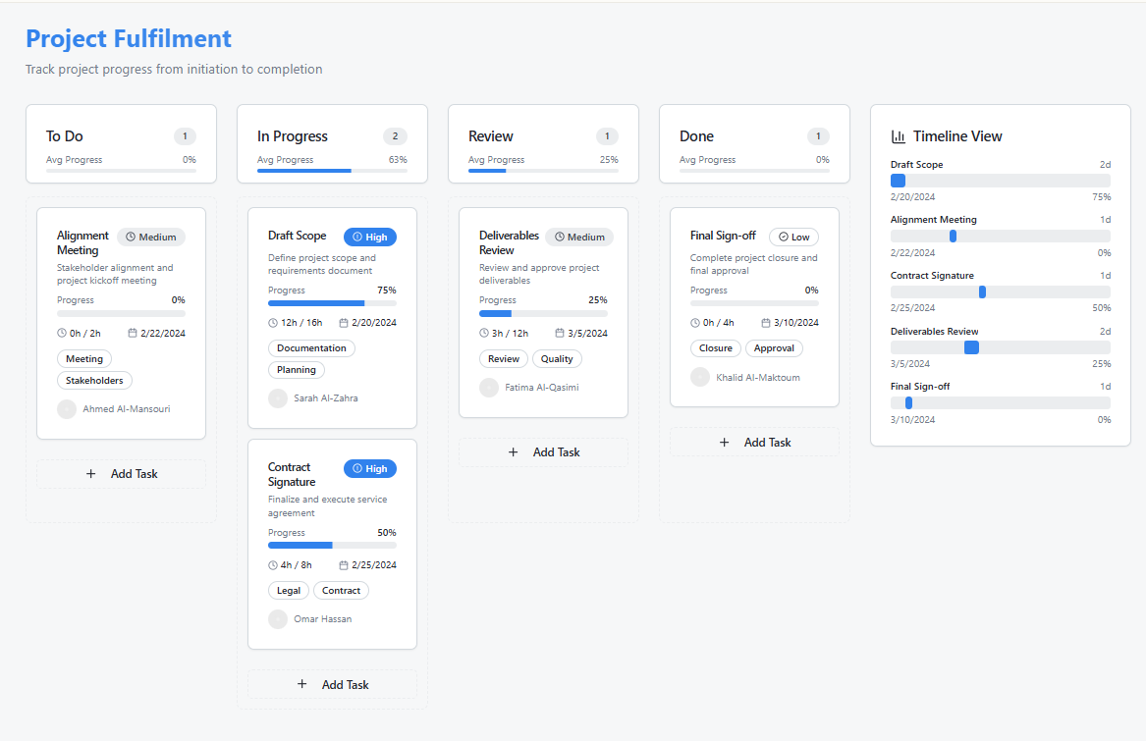
Figure 08 — Retainer Fulfilment Orchestration
Purpose: Displays recurring service tickets grouped by month. SLA compliance shown with green/amber status pills; includes vendor assignment and CSAT scores.
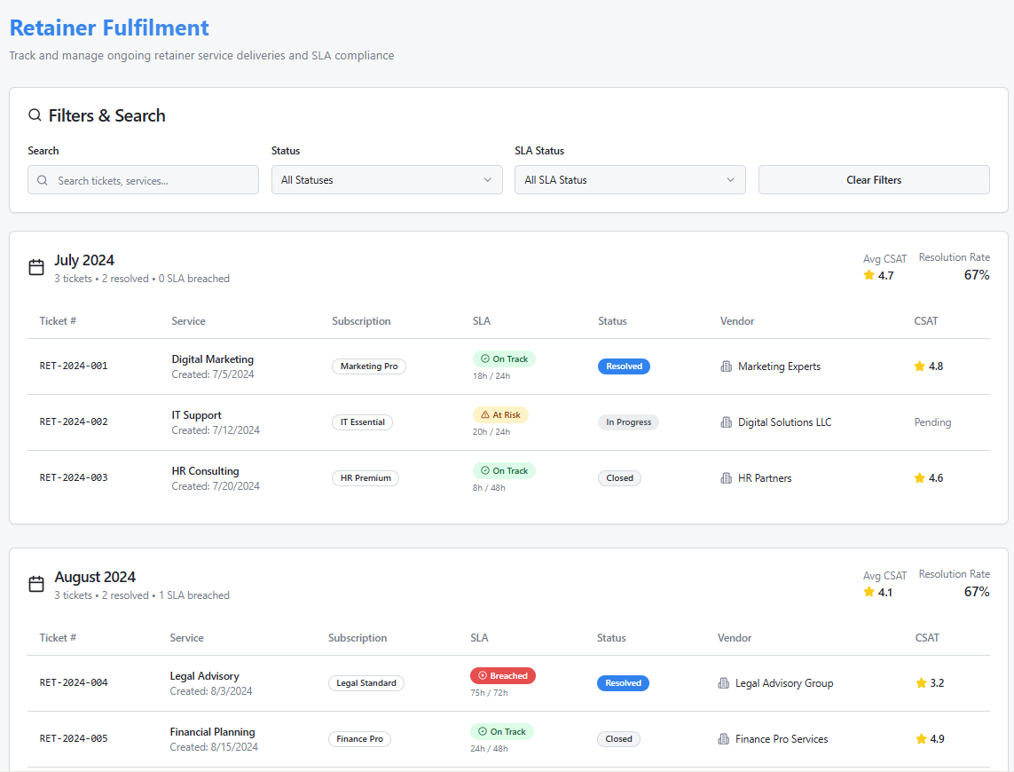

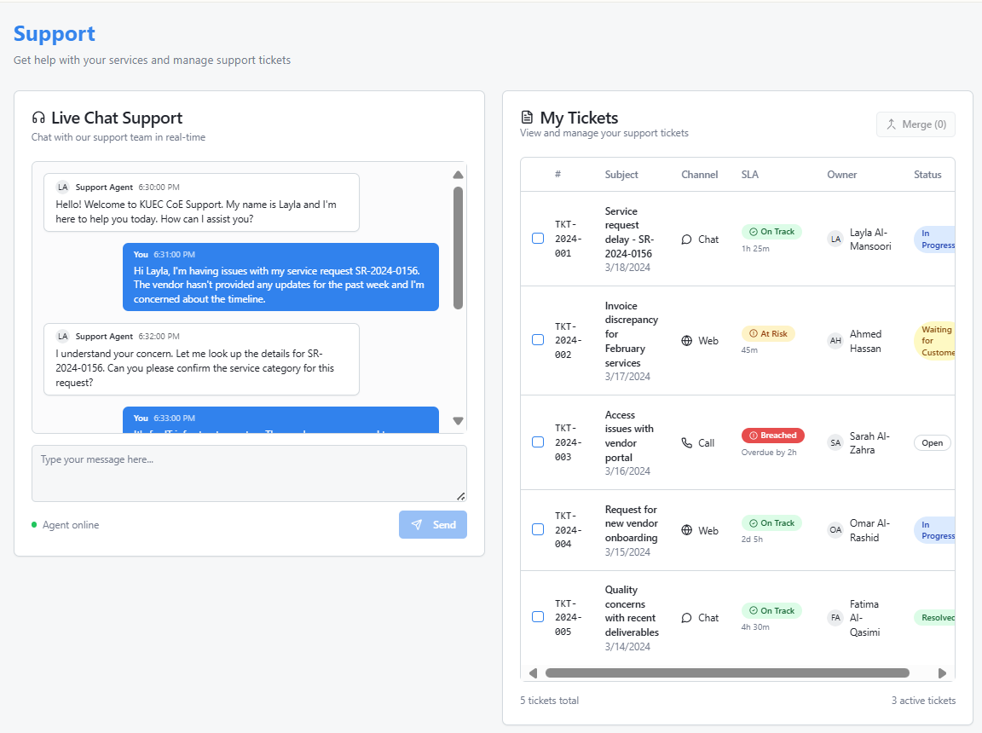
Figure 9 — Customer Support (Chat & Ticket Tracking)
Purpose: Integrated customer support view. Live chat transcript on left; ticket list on right with ability to merge duplicates.

Conclusion
The proposed KUEC Partner Self-Service Catalog Portal has been meticulously mapped and visualized based on the BRD and Service Catalog requirements. With the use of Odoo 18 EE as the foundation, the solution delivers an intuitive, fully integrated, and scalable platform capable of supporting all KUEC operations—from registration and vendor collaboration to invoicing and reporting. Each core requirement has been addressed through Odoo's out-of-the-box capabilities, with additional customization and integration planned where necessary to meet specific needs.
Key Points:
- Optimized Solution: The solution leverages Odoo's full capabilities, ensuring minimal development time while maximizing functional benefits, particularly in the areas of registration, customer service, and financial management.
- Realistic Visualizations: High-fidelity mockups allow KUEC stakeholders to easily visualize the end-user experience and the impact on their operations.
- Scalable Roadmap: Future-proof integrations (e.g., AI routing, Power BI analytics) are seamlessly aligned to Odoo’s extensible framework, providing a growth path for the portal.
- Training and Support: The training approach ensures that KUEC’s teams—ranging from vendors to internal departments—are equipped with the skills and knowledge to operate the portal efficiently from day one.
In summary, this proposal outlines how Kaizen Principles will work collaboratively with KUEC to implement a robust, efficient, and future-oriented self-service portal, leveraging Odoo 18 EE and enhancing it with necessary customizations. This will not only fulfill immediate operational requirements but will also lay the foundation for sustained growth, efficiency, and innovation within KUEC’s shared service model.

